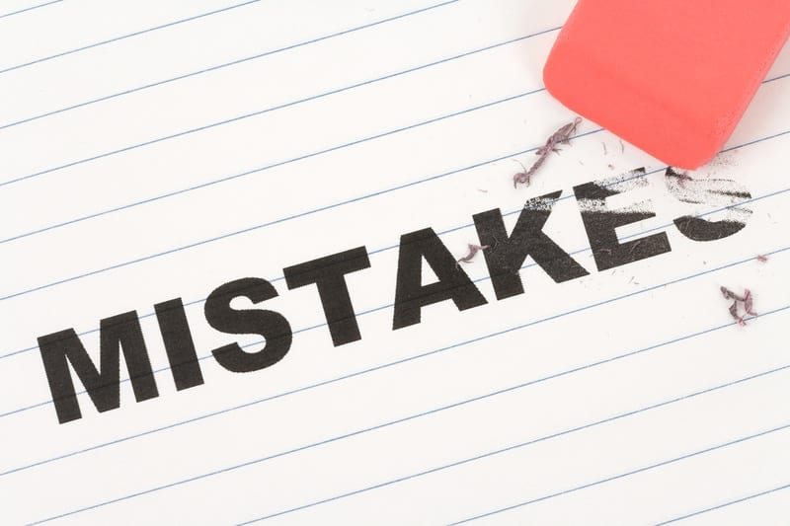
TOP 10 MISTAKES COMMUNITY OWNERS MAKE THAT RESULT IN AVOIDABLE LIABILITY LOSSES

- Failing to consistently and respectfully enforce all park rules. Clean, well managed parks with consistent rules stay fuller. You might make Bubba unhappy when he has to remove his junker car, but you made all your other tenants happy;
- Using uninsured contractors. When they cause problems, you are left holding the bills;
- Failure to use Performance Agreements/Contracts with all contractors. Written agreements save lots of time and money when things turn sour;
- Allowing tenants to own dangerous dogs...Chows, pit bulls, wolf hybrids, German Shepards, and Rottweilers are too dangerous. They cause park owners large losses;
- Failure to make sure all public walkways and streets are free from slip and fall hazards. Slip and falls are the number one cause of loss for park owners;
- Being too friendly or too combative with tenants. The best managers are consistent, direct and respectful, but not friends with tenants;
- Deferring maintenance on rental homes. These can be excellent investments, but must be properly maintained. Many of the largest liability losses are the result of poor home maintenance;
- Neglecting to have sturdy steps with handrails and working smoke detectors in all park owned homes. These are minimum requirements;
- Not meeting all safety codes and requirements with a pool. The risks for pools are manageable, but fences and safety equipment must be 100% up to code 100% of the time;
- Failing to have management walk the park regularly. Great way to find out what is going on in your park, and get rid of hazards like trampolines, kiddie pools, and other attractive nuisances before they bite you.

Kurt D. Kelley, J.D.
President, Mobile Insurance
Kurt@MobileAgency.com
www.mobileagency.com

President of Mobile Insurance, an agency specializing in insurance for manufactured home communities and retailers. Named top commercial insurance agency by American Modern Insurance Group. Member of numerous insurance companies’ policy development and advisory teams. One of largest manufactured home specialty agencies in the country. 2017- Present Founder and Publisher of the Manufactured Housing Review, an industry publication dedicated to Manufactured Home Industry professionals. www.manufacturedhousingreview.com
