Tips for Keeping Your Community Out of Lawsuits
COMMUNITY MANAGEMENT & FAIR HOUSING (LEGAL)
- by Robert S. Coldren
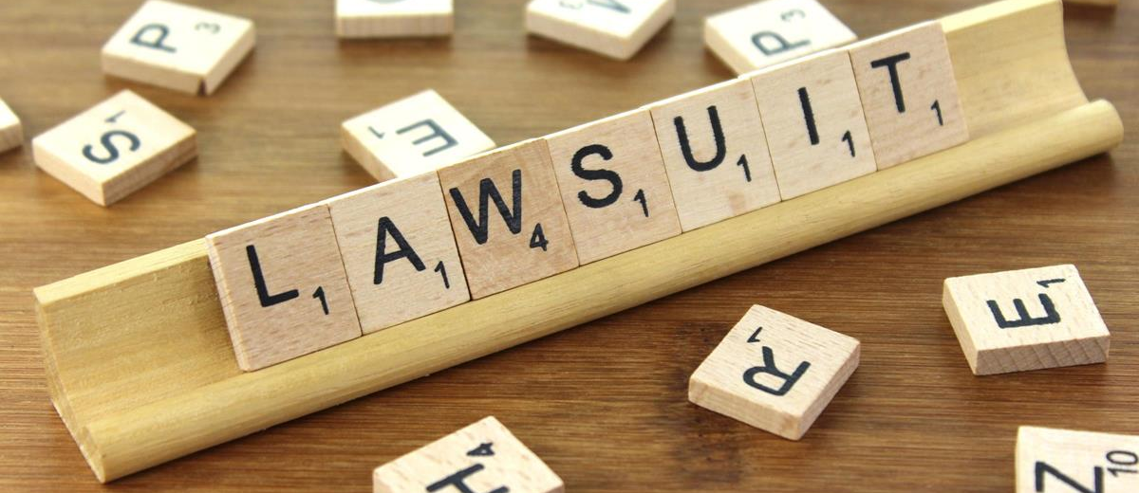
Although it may be impossible to prevent every lawsuit regarding a manufactured housing community, Hart, King & Coldren has outlined several tips, gathered from our experience representing manufactured community owners, which can help reduce your exposure to frivolous and preventable lawsuits.

· Comprehensive residency application: By creating a comprehensive residency application, you can discover far more information about the residents and their qualifications to rent a home site in your community. By discovering this information earlier, your managers are better able to filter out potential disruptive or troublesome residents before they reside in your community. Caveat: State law, such as the California Mobile Home Residency Law, may limit the grounds for denying an application for tenancy – so do not ask for information you cannot use.

· Long Term Leases: Long Term Leases may exempt the community from rent control. Although some communities may not currently be in rent control jurisdictions, there is still the ever-present risk that rent control will be adopted.

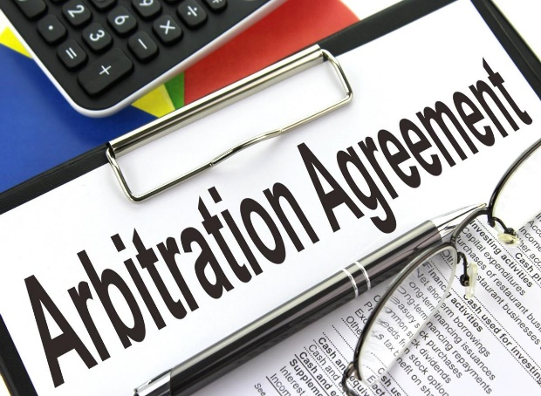
· Alternative Dispute Resolution Agreements: Offer arbitration and mediation agreements. Such agreements allow disputes between the community and the community residents to be resolved by a relatively informal proceeding, rather than trial, avoiding the considerable costs and uncertainties associated with a jury trial, avoiding the considerable costs and uncertainties associated with a jury trial. Unlawful detainer actions and actions regarding rule violations should be exempted from alternative dispute agreements, to avoid delay.

· Maintain Regularly Scheduled Infrastructure Inspections: If your community does not do so already, establish regular inspections of the roads, utility systems, and infrastructure in your community. Not only will this help prevent accidents (and lawsuits) from occurring in your community, but ensuring that the roads, utility systems, and infrastructure in your community are in good repair will improve resident relations, and reflects a sense of pride in ownership for both the resident and the community owner. In addition, California and federal regulations require community owners to conduct tests of the utility systems, such as the water, electricity, gas, and fire protection systems. Other states may have similar regulations; in any case, the federal requirements apply in all states.

· Conduct Regularly Scheduled Maintenance of Common Area Facilities: Community owners are responsible for maintaining the common area facilities. By conducting regularly scheduled maintenance of the common area facilities, the community owner can prevent accidents (and lawsuits) concerning the failure to maintain the common areas of the community. Make sure that trees in the common areas are well maintained. Make sure that the pool and/or spa in your community is regularly maintained and that all rules are clearly posted. Conduct, at a minimum, yearly inspections of the exterior of residents’ homes and landscaping to ensure that the community is looking its best.

· Enforce the Community Rules Effectively: Document all violations of the community rules and regulations. Send “friendly reminders,” advising residents of the need to comply with the community’s rules and regulations. Promptly serve the appropriate notices to cure the violations. Be prepared to proceed with an injunction or termination of tenancy if the violations are not cured. Consistently enforcing your rules and regulations for all residents reduces the risk of a claim that the community is discriminating against a particular resident. Furthermore, enforcing the maintenance standards set forth in your residency documents can help reduce the risk of claims by other homeowners that their property is being devalued by deteriorated conditions in the community. Have vehicles parked in violation of community rules and regulations towed, being careful to comply with the requirements of state law regarding towing.

· Form Positive Resident Relations: Organize community social events. One excellent example is having various health organizations and the local fire department come to the community and give the residents information about their health and safety. Ice cream socials, barbeques, and holiday parties can be wonderful social events for your community that can foster positive resident relations. Develop an open-door policy that welcomes residents to discuss issues with management. Combined with the next tip, developing management policies and procedures, the open-door policy promotes positive resident relations and helps minimize lawsuits against the community by unhappy residents looking for a way to get the community owner’s attention.

· Develop Management Policies and Procedures: Develop a handbook for on-site mangers, setting forth community policies and procedures. Develop a method to organize all relevant documentation, and purge all unnecessary documents. One problem faced by many community owners is the massive amount of paperwork and records that must be retained by community mangers. Establish a document retention policy and develop a method to file, label and store all relevant documents. Investigate and follow up with resident complaints in a timely fashion. This allows you to quickly catch rule violators and remedy problems before the need to resort to legal counsel, or worse, the courts.

· Educate Your Community Managers: Conduct seminars on community policies and legal requirements applicable to manufactured home communities. A number of industry-sponsored seminars are available.
· Have Positive Involvement with Local Government: Get to know and encourage your community managers to know the local government officials. By developing a good working relationship with them, problems can be avoided or more readily resolved. Community owners and managers should be encouraged to know their local Department of Housing and Community Development (HCD) inspector, as HCD is responsible for inspecting the community common areas and mobile homes, and issuing permits for new home and accessory installations. It is also a good idea to know your local city council and local building inspector.

· Create an Emergency Preparedness Plan: Be prepared for a disaster before it happens. California, for instance, is prone to earthquakes and fires. Other areas of the United States are subject to hurricanes, typhoons and other natural disasters. Having a plan before a disaster strikes can help save lives and help prevent the community owners from being sued for negligence should a disaster occur. The Red Cross or government agencies may be able to provide guidelines for an emergency preparedness plan for your community.

· Have Adequate Liability Insurance Coverage: Finally, make sure that the community has adequate liability insurance coverage, and that the insurance is renewed on a timely basis and coverage is in existence at all times. Periodically review the coverage needs of your community to ensure that your community is adequately protected.

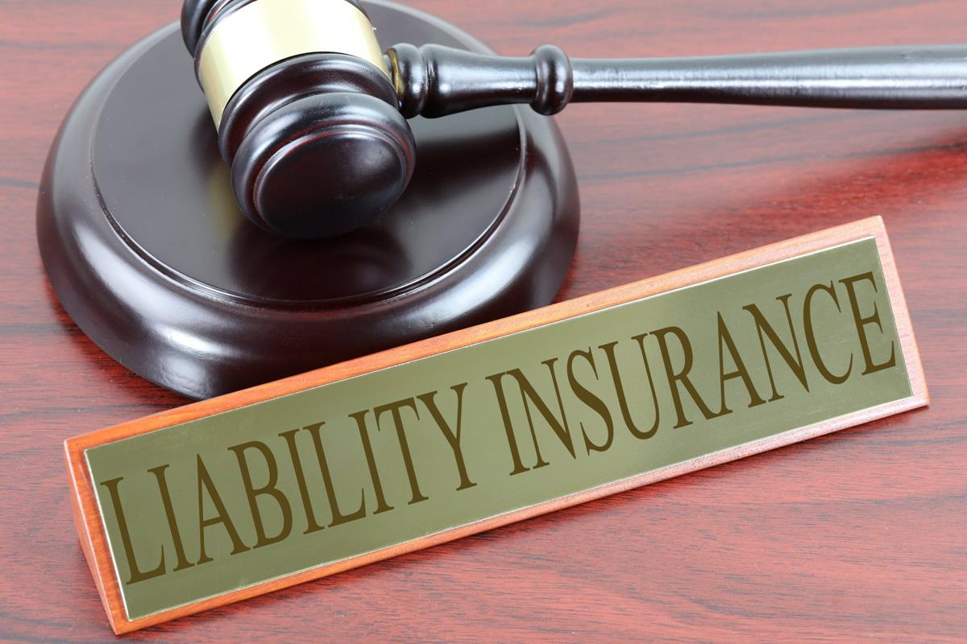

Rob Coldren enjoys a special reputation in the area of property rights, land use, and regulatory “taking” issues. His primary expertise is in legal issues pertaining to Manufactured Housing Communities and R.V. parks nationally. For over a quarter of a century, a practice group within the law firm he founded became widely recognized as the premier legal representative for the mobile home park industry, manufactured housing communities and recreational vehicle park clients throughout California. With unparalleled relationships within the industry and the communities in which he operates, Rob has been a key litigator in many of the industry’s most important cases, including the case of Guggenheim v. City of Goleta which went to the Ninth Circuit Court of Appeal. Rob is an equity and strategic partner in numerous properties, including the 304-space Huntington Shore Cliffs park and the 252-space Pacific Mobile Home Park, both in Huntington Beach, CA. Rob recently retired from the full-time practice of law at the firm he founded, Hart, King & Coldren, in order to focus on Pacific Current Partners. Along with his distinguished record and reputation as an attorney, Rob also enjoys traveling, fishing, mountain biking, skiing, surfing & paddle boarding, and more than anything else, spending time with his wife of 35+ years and their two children.
http://www.pcpequity.com/
rob@pcpequity.com

