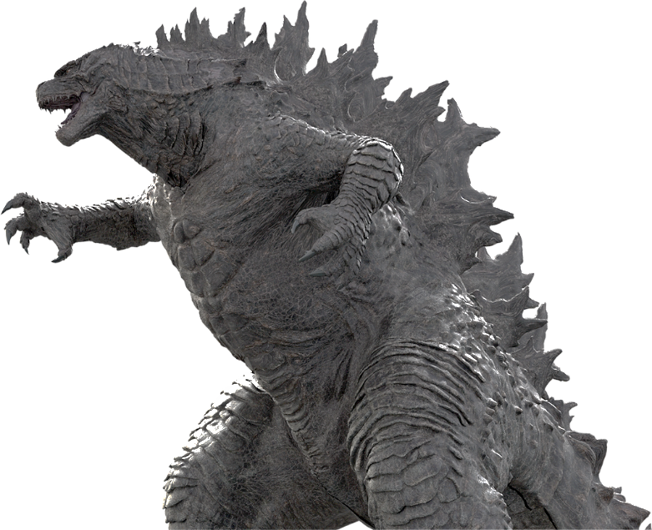
WHAT IF GODZILLA ATTACKS MY PARK?!?
A curse of being an insurance agent is that when I attend movies featuring colossal destruction, I can’t help but wonder who will pay for all that damage. Cars are flung, buildings are crunched, and Earthlings are maimed. While everyone else is enjoying popcorn and soaking up the movie, I’m thinking about insurance coverage and the resulting certainty of litigation. . So, enter my world for two minutes, and let’s think through what would happen if Godzilla attacked your mobile home park.
Billy Bob, my maintenance man, was in the tool shed when Godzilla whacked it with his tail 407.5 yards into the lake. From the look of the shed’s flight trajectory, Billy Bob won’t be doing any mowing for me in the future, nor will he be taking care of his family. Well, presuming he’s an employee and you have Workers Compensation insurance coverage, you and his family are in luck. Billy Bob was working at the time and he was mortally injured. Thus, Workers compensation will pay for any medical expenses he incurred plus income to his wife until she remarries. It will also pay income to his four kids, Burnelle, Waynette, and the twins, Daryl and Darrell, until they turn 18, or 25 if they are full time college students.
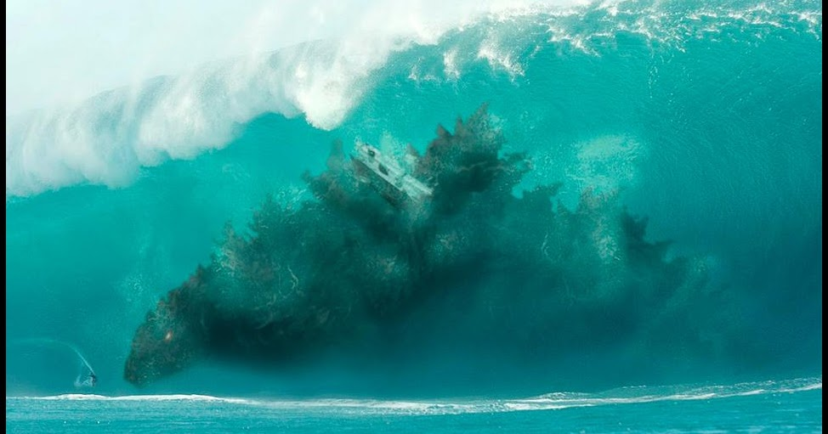Now what if Godzilla was in the lake next to my park and his body shoved a 30’ wall of water that washed away 20 park owned homes and 50 tenant owned homes. Sure enough, like almost every insurance policy written today, my policy excludes flood coverage. But wait, this isn’t rising water or a tidal flow that fits the policy’s definition of a flood. This damage was caused by an out of control animal, albeit other worldly. There’s no exclusion for damage done by animals in my Special Form property policy. So Woohoo! My park owned homes would be covered. And the loss of income associated with my former park tenants’ homes (God rest their souls) will continue to pour into my investment account!
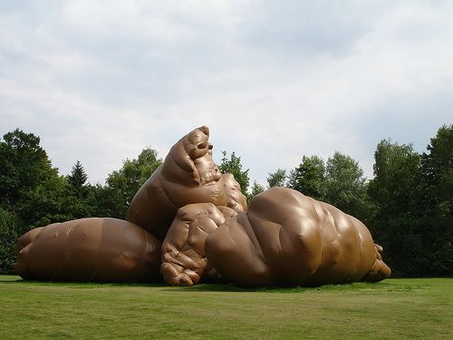Next, the 400’ tall monster walks into the middle of my park and is standing over my clubhouse when all the cars, military vehicles, and seawater he’s ingested suddenly generate massive stomach problems. The resulting epic s*#%, I mean poop, from 100’ above my building smashes the roof. Crap! Am I covered? Well, damage due to fallen objects is covered under most policies. But this is poop and poop is a pollutant. Pollution damage is excluded under almost every policy. Nevertheless, my guess is that because the “pollution” didn’t cause damage due to polluting something, it caused damage by smashing it, then it’s covered.
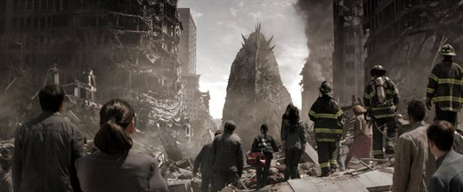
But wait, there’s more! What if Godzilla had just met, in the bowels of the earth, with Middle East extremists who’ve been rejected by women and are now hell bent on raining down retribution on us all? But worse yet, the damage is far and wide, to the point the government has become deeply involved. Will the government label this an official terrorist event? Did I take that $150 terrorism coverage rider my handsome insurance agent suggested?!? If not, I could be without coverage.
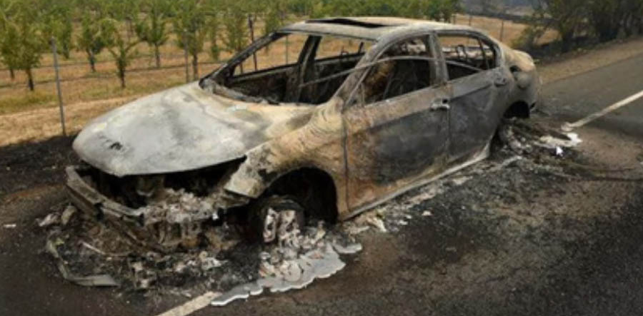And oh no! I just drove into town to visit the park in my new Porsche Cayenne. I even let some of the tenants take their picture next to it. And now, it’s been roasted into a melted ball of rubber and metal with one of Godzilla’s fire blasts, because Godzilla hates low EPA estimated MPG vehicles with a passion. Well, relax. Presuming you have “comprehensive” coverage, you should get a check for the value of the vehicle less the deductible.
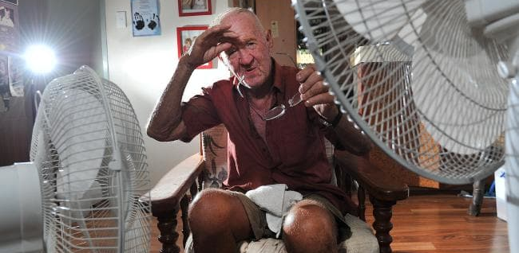Finally, what if Godzilla spared my park because he can clearly see all the quality low income housing I provide to a community that desperately needs it. He didn’t step a foot in it. But he damaged the power lines in the region so badly we are without power for 30 days. And we are in Texas! And it’s June and already 109 degrees! Thus my tenants stop paying rent and leave. Will my loss of income coverage pay? Most Special Form property policies exclude coverage for off premises caused power outages unless you specifically requested an often costly endorsement adding this coverage back. Thus, you’ll likely have to just hope your tenants keep their contractually required rent payments flowing to you.
There are lessons to be learned here. Be a good citizen. Don’t drive low MPG vehicles. Never stay in Texas during July for the whole month. And it’s ill-advised to choose a profession that will keep you from enjoying a fine Global destruction movie.
Kurt D. Kelley, J.D.
President, Mobile Insurance
Kurt@MobileAgency.com

President of Mobile Insurance, an agency specializing in insurance for manufactured home communities and retailers. Named top commercial insurance agency by American Modern Insurance Group. Member of numerous insurance companies’ policy development and advisory teams. One of largest manufactured home specialty agencies in the country. 2017- Present Founder and Publisher of the Manufactured Housing Review, an industry publication dedicated to Manufactured Home Industry professionals. www.manufacturedhousingreview.com

