“Mildred! Is that a Dog Parade?”
MANAGING THE INFLOW OF SERVICE AND EMOTIONAL SUPPORT ANIMALS – YOUR RIGHTS AND THEIR RIGHTS

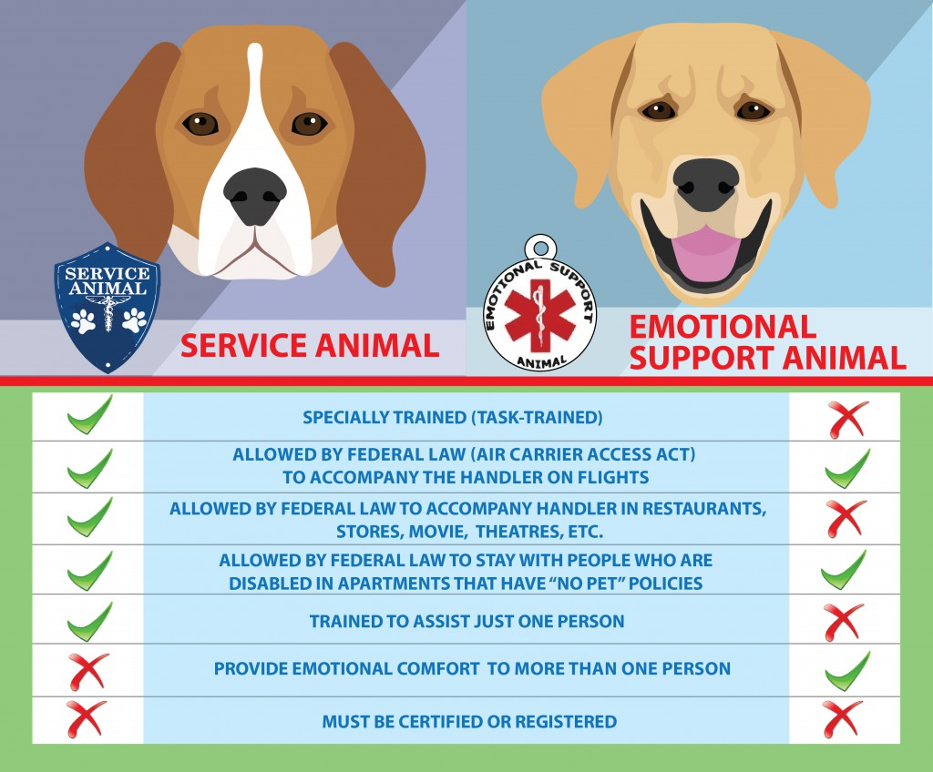

Court rulings and Federal laws have opened the door to allow a parade of dogs and other animals onto your property. In many instances, either the Americans with Disabilities Act (ADA) or the Fair Housing Act (FHA) give your tenants the right to keep an animal even though your community rules would otherwise prohibit such. Disabled people may request that they be allowed to keep “service animals” and “emotional support animals.” Presuming the tenant and animal meet the proper definitions, community management must allow the animal to remain in the park. A “service animal” is defined as a dog that is trained to do work or perform specific tasks for a person with a disability. “Emotional Support Animals” are broadly defined as any animals, whether trained or not, that provide emotional support and alleviate symptoms of a disability.

First, it’s important to know what you can’t do as a property manager.
You cannot…
- ask what the person’s disability is;
- ask for medical documentation;
- ask that the animal demonstrate its skill or seek a certificate from the Service Dog’s Trainer;
- charge an extra fee for the right to keep the animal; or
- discriminate based on the perceived severity of a disability. For example, you can’t allow accommodations for a paraplegic in a wheel chair while not allowing accommodations to another who has no readily visible disability.

Second, it’s important to know what you can do as a property manager.
You can…
- demand the animal owner keep the animal in their control at all times;
- ask if the animal is a service animal that is required due to a disability;
- ask what type of work or task has the animal been trained to do;
- remove any animal that is a known danger to others in your community;
- prohibit the animal from coming into your buildings if it isn’t housebroken; and
- require that every tenant seeking an exception complete and sign the “Service Animal from Tenant to Management Affirmation” found in the “Loss Control” section of our website www.mogileagency.com .

This letter requires the tenant to make specific affirmations and provide verifications from third parties that the animal is an “emotional support animal.” The verification should be from a Health Care Provider in the case of an emotional support animal. The definition of a “Health Care Provider” isn’t limited to a medical doctor.

This article is a short summary of a complicated topic, so be sure to visit with your own counsel for more specific questions. Though the law has taken away some of your authority to manage your property as you choose, it’s important to know what authority you retain. Using the “Service Animal from Tenant to Management Affirmation” letter will give pause to those tenants that would bring in pets that aren’t truly support animals and would otherwise not be allowed. And knowing you don’t have to allow a dangerous animal to reside in your community is a comforting thing.

Kurt D. Kelley, J.D.
President, Mobile Insurance
Kurt@MobileAgency.com
www.mobileagency.com

President of Mobile Insurance, an agency specializing in insurance for manufactured home communities and retailers. Named top commercial insurance agency by American Modern Insurance Group. Member of numerous insurance companies’ policy development and advisory teams. One of largest manufactured home specialty agencies in the country. 2017- Present Founder and Publisher of the Manufactured Housing Review, an industry publication dedicated to Manufactured Home Industry professionals. www.manufacturedhousingreview.com

