JUSTICE ANTONIN SCALIA:
A VERDICT BY A COUPLE MANUFACTURED HOME INDUSTRY LAWYERS

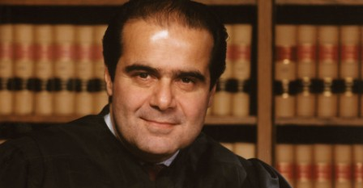

THE JUDGMENT - A differentiating feature between an economically vibrant country and a Banana Republic is the functionality of their respective judicial systems. In the former, the law is clear. People understand that it will be justly administered. As a result, commerce blossoms. Contracts are entered into. Predictability rules. In a Banana Republic, the law depends on who you are, how much money you have, and what the Ruler of the day says it is. As a result, commerce withers. The risk of proceeding is too great. And society is poorer.

Justice Antonin Scalia gave America its most straight forward judicial philosophy. He believed the Constitution didn’t magically change over time. It means what it says and says what it means. When Constitutional language is subject to interpretation, Justice Scalia said it means what society treated it as meaning during the timeframe during and shortly after it was written. He added that if anyone didn’t like what the Constitution said, they could try to change it legislatively. He championed that the idea of a “Living Constitution” is counter intuitive to America’s governmental structure. He wrote, “It’s up to elected officials to change laws. The role of judges is to interpret law. Each branch of government has the authority granted to it by the Constitution, no more, no less.”

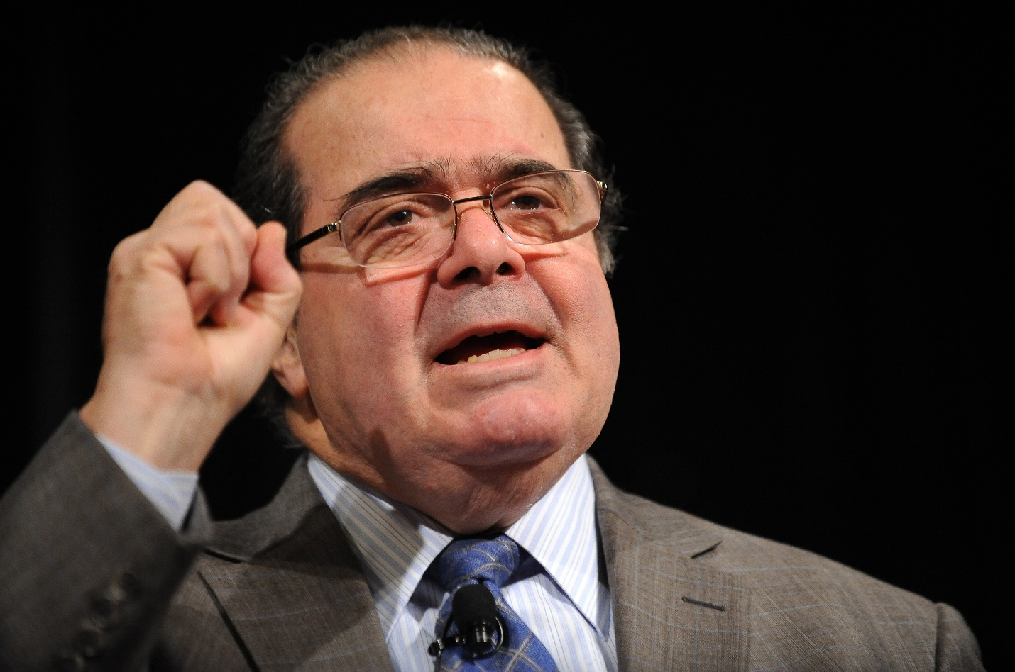
While he was labeled a political conservative, a more accurate description is a judicial conservative. He was a lightning rod for criticism from liberals, yet he was respected by them, too. Ted Kennedy said he had a brilliant mind. Justice Scalia enjoyed widespread respect because he applied the same judicial philosophy to a case, no matter what the outcome. For instance, to the dismay of some conservatives, he ruled that: the government can’t outlaw flag burning, because that’s freedom of speech and absolutely protected; if a jury in Mississippi wants to award some dope with a scratched BMW $2.1 million, they can, because the Constitution doesn’t say they can’t; and if an accused molester wants to cross examine a child he can, because the Constitutional right to cross examine doesn’t say sometimes, or often.

Justice Scalia was admired by such a wide cross section of people because he based rulings on the written law, not what he wanted it to be. Some of Justice Scalia’s best lines were written in dissents. He wrote in a case regarding sodomy, “Today’s (majority) opinion, has no foundation in American Constitutional law, and barely pretends to.” When explaining why the court should not try to create a legal standard for artistic value in an obscenity case, he said, “It’s quite impossible to come to an objective assessment of artistic value, there being many accomplished people who find art in the replication of a soup can.”

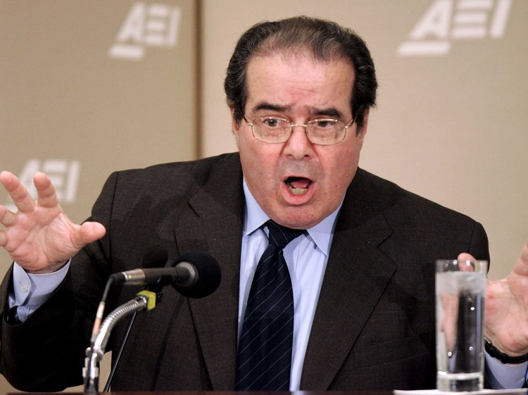

When the Court outlawed any prohibition of same sex marriage, he dissented and wrote,
“This is a naked judicial claim to legislative, indeed super –legislative power; a claim fundamentally at odds with our system of government. Accept as limited by the Constitution, states are free to adopt laws they like, even those that offend the esteemed justices’ ‘reasoned judgment.’ A system that makes the People subordinate to a committee of nine unelected lawyers does not deserve to be called a Democracy.”

When a lawyer before him argued that the Court could not rely on the testimony of witnesses who saw the face of an alleged killer, he answered, “Facial features are the primary means by which humans recognize each other. That’s why police have mug shots… It’s why robbers wear stockings over their faces… It’s why the Lone Ranger wore a mask instead of a poncho and it’s why a criminal defense lawyer who seeks to destroy a witness by asking, ‘So you only saw the killer’s face?’ will be laughed out of court.”

If Justice Scalia had ruled on a case affecting the Manufactured Home industry, he would have applied the law as written. A retroactive city zoning law or building code banning manufactured homes would not have stood. The Constitution forbids retroactive laws. He would not have treated us differently because we, nor our tenants, are powerful, trendy, or popular.
Justice Scalia’s disciplined legal approach remains a roadmap for judges. Law students study it due to its simplicity. In contrast, if you're a law student and fan of Justice Souter's rulings, you'll be left wanting. Justice Souter is rarely studied or quoted. From 1990 to 2004 there were 113 law review articles published with Justice Scalia’s name in them, and only five for Justice Souter. Unprincipled judicial methods don't easily lend themselves to study or teaching. Justice Scalia's philosophy will continue as a force. He is the greatest Supreme Court Justice of our lifetime.

CONCURRENCE AND CONSENT - When Kurt asked me if I wanted to write a few thoughts about the passing of Justice Scalia I initially thought that maybe I should go back through his opinions and dissents to provide some detailed analysis of the man’s career. But Kurt had already done a far superior job summarizing so many of his writings, and for me in thinking back I decided to take a 10,000 foot view of what I knew and read about Justice Scalia.

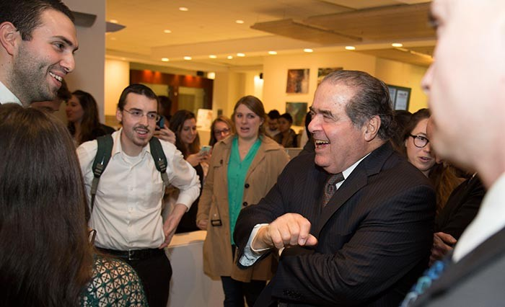

My take on him was that he demonstrated how to passionately and forcefully assert his opinions and engaged in vigorous debate. His humorous side delightfully spiced things up as well. I think Justice Scalia, who no one would confuse as a shrinking violet, embodied that intelligent debate is necessary to not only preserve our Republic, but to progress forward as a nation when tackling the hardest issues.

Not all countries solve their toughest questions with thoughtful debate. This tragedy is seen played out in authoritarian and repressive regimes not only in history but currently sharing this planet with us. And in the worst case, debate is the furthest remedy sought when confronting conflict and violence is too easily used instead.
But what I fear can get lost in not only legal battles, but also the current political discourse is the inability to disagree without demonizing those in opposition. Justice Scalia demonstrated throughout his life that it is important to express one’s opinions, however controversial, while listening to the other side. And then when he stepped out from behind the bench he would go to the person(s) he just spared with so fiercely and could not only maintain civil discourse, but actually befriend them.

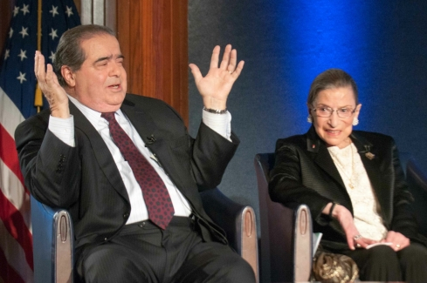One of Justice Scalia’s closest friends was Justice Ruth Bader Ginsburg. The two justices could not be further apart on the political spectrum, and yet they were close friends for decades. She is quoted as saying they, “were best buddies.” She went on to acknowledge that his dissents made her opinions better. And that is what sharp, respectful, vigorous debate should do. Like sharpening a knife on a wet-stone, when pressed in opposition one’s argument must improve, must sharpen, must rise in both thought and articulation. When this can occur, all benefit.

So my big take away from the passing of the man Justice Breyer called appropriately, “a legal titan,” is that we should disagree, we should question, we should assert passionately our opinions, and we should press the opposition. But we must also remember the people who disagree with us are just that people. Respect, dignity, truly listening and observing their point of view and even the capacity for friendship should be at the core of everyone’s discourse. This is what makes our country great, and when we depart from these principals our country suffers.

Whatever it is we will face, whether disagreements at work, political opinions with the coming elections, or serving on a neighborhood HOA arguing over which parking lot gets repaved first, we should use Justice Scalia as an example and when all is said and done and the chips have fallen either in or out of our favor, be sure we all reach our hand out to the other side. There are far too many people willing to declare those who disagree with them as their enemies, but what pushes us toward greatness is to be able to disagree and love, not disagree and hate.

DJ Pendleton, J.D., is the Executive Director of the Texas Manufactured Housing Association dpendleton@texasmha.com
www.texasmha.com
(Though they sometimes disagree, they remain good buddies)

Kurt Kelley, J.D., is President of Mobile Insurance
kurt@mobileagency.com
www.mobileagency.com
Publisher of the Manufactured Housing Review Magazine
www.manufacturedhousingreview.com

